Music Notes

Scales

* **How to build a major scale**
  + Ws – whole step
  + Hf – half step
  + R – root note
  + FORMULA - r, **WS, WS, HF, WS, WS, WS, HF**
* **How to build a minor scale – (natural)**
  + Ws – whole step
  + Hf – half step
  + R – root note
  + FORMULA - r, **WS, HF, WS, WS, HF, WS, WS**

Note -

* c major scale and a minor scale has same set of unique keys
* Count 3 half steps from minor key to get the major key which has unique keys.
* A + hf + hf+ hf = c
* So a minor and c major have same keys
* **How to build harmonic minor scale**
  + Ws – whole step
  + Hf – half step
  + R – root note
  + FORMULA - r, **WS, HF, WS, WS, HF, 1.5 WS, WS**

Note –

* The difference between the natural and harmonic minor scale is only the seventh note .
* Seventh note is half step higher.
* **How to build a melodic minor scale**
  + Ws – whole step
  + Hf – half step
  + R – root note
  + FORMULA - r, **WS, HF, WS, WS, ws, WS, hf**

Note –

* The difference between the natural and meloic minor scale is only the sixth and seventh notes.
* Sixth and seventh notes are a hf higher.
  + If we play the ascending melodic minor scale then we can play the descending natural minor scale
* **How to build jazz minor scale**
  + it is derived from ascending melodic minor scale.
  + The ascending and the descending are the melodic minor scales

**Summary of all the scales –**

* **Major -** r, **WS, WS, HF, WS, WS, WS, HF**
* **Minor -**  r, **WS, HF, WS, WS, HF, WS, WS**
* **Harmonic minor -** r, **WS, HF, WS, WS, HF, 1.5 WS, WS**
* **Melodic minor -** r, **WS, HF, WS, WS, ws, WS, hf**
* **Jazz minor -** r, **WS, HF, WS, WS, ws, WS, hf**

**Scale degrees**

* **Major scale degrees -** 
  + Tonic, supertonic, mediant, subdominant, dominant, submediant,

Leading tone , tonic

* **Natural Minor scale degrees –**
  + Tonic, supertonic, mediant, subdominant, dominant, submediant,

Sub tonic , tonic

* **Harmonic minor scale degrees –** 
  + Tonic, supertonic, mediant, subdominant, dominant, submediant,

Leading tone , tonic

* **Melodic minor scale degrees –** 
  + Tonic, supertonic, mediant, subdominant, dominant, submediant,

Leading tone (asc) or suntonic (desc) , tonic

**Music intervals**

* **Major, minor and perfect intervals –**
  + Reference/starting key = perfect unison
  + Major 2nd – 2 hf away from perfect unison
  + Major 3rd – 4 hf away from perfect unison
  + Perfect 4th - 5 hf away from perfect unison
  + Perfect 5th - 7 hf away from perfect unison
  + Major 6th - 9 hf away from perfect unison
  + Major 7th - 11 hf away from perfect unison
  + Perfect 8th - 12 hf away from perfect unison

**Note – a minor interval is a hf less than a major interval**

* **Diminished and augmented intervals –** 
  + A DIMINISHED INTERVAL IS A HF LESS THAN A PERFECT INTERVAL
  + A DIMINISHED INTERVAL IS A HF LESS THAN A MINORINTERVAL
  + AN AUGMENTED INTERVAL IS A HF MORETHAN A PERFECT INTERVAL
  + AN AUGMENTED INTERVAL IS A HF MORETHAN A MAJOR INTERVAL
* **TRITONE –** 
  + TRITONE IS 3 WS FROM THE ORIGINAL KEY
  + IT IS SAME AS THE DIMINISHED 5TH OR AUGMENT 4TH

**Chord and harmony**

* **Chord –** 
  + A chord consists of 3 or more musical notes played simultaneously at same time
  + Power chord consists of only 2 musical notes simultaneously at same time
  + Broken chord is a sequence of notes that a chord consists of
  + An arpeggio is a type of broken chord in which the notes that make up the chord is played in asc and desc order
* **Harmony –** 
  + a harmony is when you play two or more notes simultaneously at same time

**TRIAD CHORDS (key)**

* **MAJOR TRIAD CHORD –** Root +major 3rd + perfect 5th
* **MINOR TRIAD CHORD –** Root +minor 3rd + perfect 5th
* **DIMINISHED TRIAD CHORD –** Root +minor 3rd + diminished 5th
* **AUGMENTED TRIAD CHORD –** Root +major 3rd + augmented 5th

**Major scale triad chords**

* **Chord 1 - MAJOR**
* **Chord 2 - MINOR**
* **Chord 3 - MINOR**
* **Chord 4 - MAJOR**
* **Chord 5 - MAJOR**
* **Chord 6 - MINOR**
* **Chord 7 - DIMINISHED**
* **Hint – root + skip next note in the scale + skip next note in the scale**

**Natural minor scale triad chords**

* **Chord 1 - MINOR**
* **Chord 2 - DIMINISHED**
* **Chord 3 - MAJOR**
* **Chord 4 - MINOR**
* **Chord 5 - MINOR**
* **Chord 6 - MAJOR**
* **Chord 7 - MAJOR**
* **Hint – root + skip next note in the scale + skip next note in the scale**

**melodic minor scale triad chords**

* **Chord 1 - MINOR**
* **Chord 2 - MINOR**
* **Chord 3 - augmented**
* **Chord 4 - MAJOR**
* **Chord 5 - MAJOR**
* **Chord 6 - DIMINISHED**
* **Chord 7 - DIMINISHED**
* **Hint – root + skip next note in the scale + skip next note in the scale (aug 1.5 hs)**

**harmonic minor scale triad chords**

* **Chord 1 - MINOR**
* **Chord 2 - DIMINISHED**
* **Chord 3 - augmented**
* **Chord 4 - MINOR**
* **Chord 5 - MAJOR**
* **Chord 6 - MAJOR**
* **Chord 7 - DIMINISHED**
* **Hint – root + skip next note in the scale + skip next note in the scale (aug 1.5 hs)**

**summary -**

* **MAJOR CHORDS FAMILY - M, m , m, M, M, m, d**
* **Minor chords family -** **m, d, M, m, m, M, M**
* **Hint –** the 1st chord in minor scale is same as the 6th chord in major scale (+5)
* **Melodic Minor chords family - m, m, A, M, M, d, d**
* **Harmonic Minor chords family – m, d, A, m, M, M, d**
* **Diatonic chord –**
  + A chord which is present in both major and minor scales Is a diatonic chord

**Other chords**

* **Major sixth chord -** root + major 3rd + perfect 5th + major 6th
* **Minor sixth chord** - root + minor 3rd + perfect 5th + major 6th
* **Major seventh chord -** root + major 3rd + perfect 5th + major 7th
* **Minor seventh chord -** root + minor 3rd + perfect 5th + minor 7th
* **Suspended 2nd chord -** 
  + major 3rd or minor 3rd is replaced by major 2nd
  + root + major 2nd + perfect 5th
* **Suspended 4th chord –** 
  + major 3rd or minor 3rd is replaced by perfect 4th
  + root + perfect 4th + perfect 5th
* **dominant seventh chord -** root + major 3rd + perfect 5th + minor 7th
* **diminished seventh chord -** 
  + root + minor 3rd + diminished 5th + diminished 7th
* **half diminished seventh chord -**
* root + minor 3rd + diminished 5th + minor 7th
* **augmented major seventh chord -**
  + root + major 3rd + augmented 5th + major 7th
* **augmented minor seventh chord -**
  + root + major 3rd + augmented 5th + minor 7th
* **minor major seventh chord -**
  + root + minor 3rd + perfect 5th + major 7th
* **scale seventh chords -**
  + triad + 1ws
* **Added tone chord –** 
  + It is a chord when a note is added to it
  + Added note can only be a 2nd , 4th , 6th, 9th, 11th, or 13th .
  + Triad chord + added note

**PENTATONIC SCALES**

* **Major pentatonic scales –** 
  + It is made up of 1st, 2nd, 3rd, 5th, 6th and the 8th notes of a major scale
  + 4th and 7th notes are not used
* **Minor pentatonic scales –** 
  + It is made up of 1st, 3rd, 4th, 5th, 7th and the 8th notes of a major scale
  + 2nd and 6th notes are not used

**Blues scale**

* Adding the note between the 3rd and 4th notes of the minor pentatonic scale will give you the blues scale
* Formula - r, 1.5ws, ws, hf, hf, 1.5 ws, ws

**Chromatic scale**

* **Formula –** r,hf, hf, hf, hf, hf, hf, hf, hf, hf, hf, hf, hf

**Triad/seventh chord inversions**

* Changing the order of the notes of a chord
* C-e-g 🡪 e-g-c (1st inv) 🡪 g-c-e (2nd inv)
* C-e-g-b 🡪 e-g-b-c (1st inv) 🡪 g-b-c-e (2nd inv) 🡪b-c-e-g (3rd inv)

**Circle of fifths**

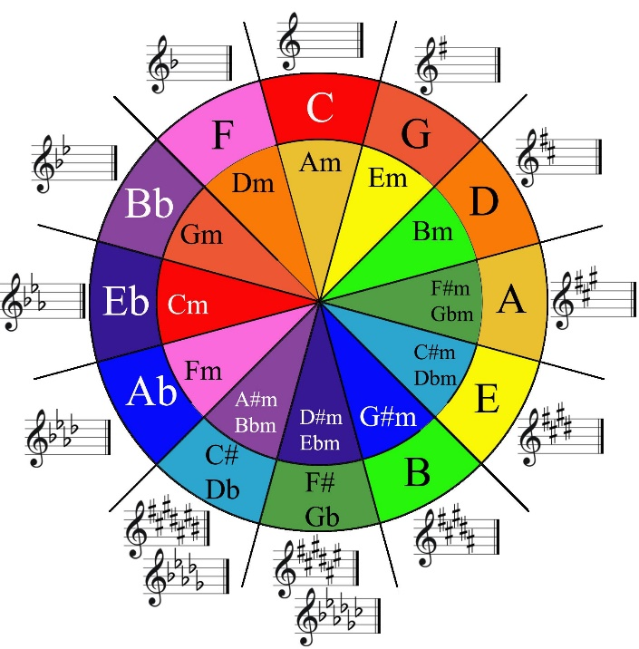

* **Create major triad chords using circle of fifths**
  + C – c + g + count 4 forward from c = c + e + g
* **Create minor triad chords using circle of fifths**
  + C – c + g + count 3 backward from c = c + eb + g
* **Find out how many sharps or flats are there in a major scale**
* C – 0# , g – 1#, d – 2#, a – 3#, e – 4#, b – 5#, f# - 6#
* c – 0b , F – 1b , bb – 2b, eb – 3b, ab – 4b, db – 5b

**Find out the relative major and minor scales using circle of fifths**

* **major key + count 3 forward**
  + c + 3 = a so c major is relative to a minor
  + ab + 3 = f so ab major is relative to f minor
* **minor key + count 3 backward**
  + **eb + 3 = f# so eb minor is relative to f# major**

**primary and secondary chords in scales**

* primary chords – 1, 4 and 5
* secondary chords – 2, 3, 6 and 7
* applicable to all the scales
* primary chords are very important